1BM24CS286 28/11/2025

1.
use Student
already on db Student
db.createCollection("Student")

o/p:
{ ok: 1 }

2.
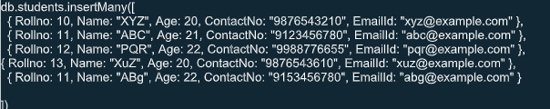
O/P:
{
acknowledged: true,
insertedIds: {
'0': ObjectId('692967d888a945d2387749ec'),
'1': ObjectId('692967d888a945d2387749ed'),
'2': ObjectId('692967d888a945d2387749ee'),
'3': ObjectId('6929680988a945d2387749ef'),
'4': ObjectId('6929680988a945d2387749f0')
}
}

3.
db.Student.updateOne(
{ Rollno: 10 },
{ $set: { EmailId: newxyz@example.com } }
);
o/p:
{
acknowledged: true,
insertedId: null,
matchedCount: 1,
modifiedCount: 1,
upsertedCount: 0
}

db.Student.updateOne(
{ Rollno: 11, Name:ABC },
{ $set: { Name: FEM } }
);

o/p:
{
acknowledged: true,
insertedId: null,
matchedCount: 1,
modifiedCount: 1,
upsertedCount: 0
}
5.
db.Student.deleteOne(
{ Rollno: 11 }
)
o/p:
{
acknowledged: true,
deletedCount: 1
}
6.
db.students.drop()
o/p:
true

